Course Rep Handbook 2024-25

warwicksu.com/sslc

Contents Welcome!

03 Welcome from [Name] and [Name]
04 Rep Wins
06 Your Role
08 Academic Reps Structure
10 Events & Activities
- Interview with a Course Rep
- Gathering and Presenting Feedback
- Where to Present Feedback
- FAQs
- Who are the SU
Education Team?
Hi! We are [Name] and [Name], your Vice Presidents for Education and Postgraduate Students at the Students’ Union.
We represent your academic interests at Warwick and fight for positive change to the educational experience of all undergraduate and postgraduate students, especially those whose voices are often underrepresented or marginalised.
The Rep System is integral to the purpose of the Students’ Union, which is to positively impact students’ lives at Warwick and beyond. Throughout the course of the year,
we’ll be collaborating with you as Course and Faculty Reps to bring about positive improvements within academic departments. As a community of Reps, you will have the opportunity to impact the quality and direction of teaching, learning, and
academic experience here at Warwick. Moreover, what you do here could affect national Higher Education policy! In the past, the amazing work of Course Reps have led to some great achievements.
In our roles as Vice President Education and Postgraduate Officers, we will support you by escalating your feedback to the University, supporting your campaigns, letting you know what we are working on and getting your views so that we can create change at a University-wide level.
So, look out for our regular newsletter to keep up with what we and your fellow Course, Department and Faculty Reps are achieving across the University and beyond.
Finally, thank you and congratulations on becoming a Course Rep! Together, we can represent student voices and improve the academic experience for all.

Name
(Pronouns)
education@warwicksu.com
Name
(Pronouns)
postgrads@warwicksu.com

Pictures

2 3

Rep Wins

Course Reps create many changes through their SSLCs (Student Staff Liaison Commitee) to improve the student experience for their cohort. Here are some achievements by SSLCs in the 2020/21 Academic Year.

Faculty of Arts
PGT History – Ran drop in sessions led by Course Reps to support students
School of Creative Arts, Performance & Visual Cultures - Lobbied for the creation of School Level newsletters for consistency of information and School connection to students
UG German - Developed a confidential channel for disabled students to
give honest feedback around their experiences – created from the Warwick Enable & SU Education Team Training

Faculty of Science, Engineering & Medicine
PGT Life Sciences – Pub Quiz Social Event & Careers Fair

PGT Computer Science – Helped changed the way labs were organised based on student feedback

UG MBChB – Establishing a new mentoring scheme with the help of MBChB students and supporting the development of our community through newsletters

Faculty of Social Sciences
PGR Sociology – Establishment of a Microsoft Teams group for students to interact and present papers to each other for peer review

UG Law - Hosted a digital module fair and created an SSLC Quiz which gained 300 responses for them to present to staff

UG PPL SSLC - Lobbied their department to hold more ‘PPL-focused’ events and socials

If you have achieved something great within your SSLC and want to share it with all Course Reps, email studentvoice@warwicksu.com and we can feature you in our newsletter and/or website.

5

4

Your Role

You have been elected to represent your cohort at a course level. Depending on the size of your year group, you may have more than one Course Rep for your cohort. As the voice for these students, you will be gathering feedback, raising issues within your course/department, and generating change.

As a Course Rep, you will be:
Meeting and communicating regularly with your cohort to gather feedback & ideas.
Escalating course-based feedback & ideas to Student Staff Liaison
Committees (SSLCs) to co-create the curriculum.
Informing your cohort about the changes/developments due to the feedback & to students’ ideas.
Supporting the Course/Department in promoting the completion of Module Evaluations, NSS/PTES/PRES and other feedback systems to the students you represent.
Escalating non-course-related feedback and feedback that is not acted upon at course level through the Academic Representation Structure.
A full role description can be found on the SU Website under Student Voice.

Training & Support
As a Course Rep, you will have access to a wide range of training and support to develop your skills and knowledge. This will include:
‘We will be running a range of events and activities that will
help you in your role as a Course Rep, have an impact on the
University, and meet other Reps.’
Rep Training. This will happen in Term 1 (or just after your election if you don’t start in October.)
Rep Resources. On the Warwick SU website, there are a range of briefings, best practice tips from fellow Reps and other resources. If there is a topic that doesn’t have any resources, you can request this from the SU Voice Team.
Rep Newsletter. You will receive a regular newsletter that contains information around what the Education & Postgraduate Officers are doing, Rep wins, new resources available, and what is happening
in Warwick & Higher Education as a whole.
Events & Activities. We will be running a range of events and activities that will help you in your role as a Course Rep, have an impact on the University, and meet other Reps. You can find out more on Page 10 or on the Warwick SU website

6 7

Academic Reps Structure
The Academic Reps Structure has multiple levels of reps and meetings so that feedback can be given, and change can happen.

Representatives |  | University Meetings | SU Meeting
Whole University | Full-Time Officers  The Vice President Education & Postgraduate Officers  are elected to represent student interests  in Education and Postgraduate experience | SLEEC, AQSC, BGS  & More  Full-Time Officers and Faculty Reps attend a wide range of meetings that change all aspects of your academic experience. | Academic Representation Forum  The Education Officer & Postgraduate Officer sit on Academic Representation Forum with the Faculty Reps to discuss University level feedback.
Faculty | Faculty Reps  Faculty Reps are elected for each Faculty to represent student  interests of their Faculty. | Faculty Education Committees (FECse)  Faculty Reps raise the Faculty level feedback given at Faculty Forums to FECs.
Course | Course Reps  Course Reps are elected per course, per year of study to represent student interests of their cohort. | Student Staff Liaison Committees (SSLCs Network)  SSLCs are a partnership between the University & Students’ Union. This is where course-level feedback that Course Reps have received from their cohort can be raised.
Student | SSLC Network  SSLC Chair is elected by course reps on a particular course to lead the SSLC Meetings.
Committee | Description
Faculty Education Boards (FEB) | The main purpose of the Boards is to consider the faculty-level implementation of University Education Strategy. There exists the Board of the Faculty of Arts, the Board of the Faculty of Social Sciences, and the Board of the Faculty of Science, Engineering, and Medicine.
Board of Graduate Studies (BGS) | BGS focuses on the postgraduate student experience. Faculty Reps who represent postgraduate students and the Postgraduate Officer are the student representatives on this meeting.
Academic Quality Standards Committee (AQSC) | AQSC focuses on the academic quality side of the student experience. The Vice President Education and Postgraduate Officers are the student representatives on this meeting.
Student Learning Experience & Engagement Committee (SLEEC) | SLEEC focuses on the general academic student experience. The Education Office Co-Chairs this meeting and the Postgraduate Officer and Faculty Reps sit on this meeting too.
Student Staff Liaison Committee (SSLC) | SSLC is the opportunity for face-to-face student feedback at a course level. These meetings are led by students, chaired and mediated by students and mainly for students to feedback to the University.
Academic Forum | Academic Forum is a body made up of all Faculty Representatives plus the Vice President of Education and Postgraduate Officer. Its key role is to direct the strategic approach and response of the Union to academic policy and educational experience of the University
Academic Resourcing Committee | The committee is responsible for guiding strategic, performance, and financial planning process for academic departments. It also assists in approving and monitoring staffing establishment of academic departments in the ARC envelope, and to consider bids for establishment of new posts
Research Committee | The RC focuses on advising the Senate on all matters relating to the research strategy at the University and identifying the priority areas for research and impact, and to develop, promote and monitor policies and practices to stimulate research and impact programmes
Academic Staff Committee | The committee is required to conduct annually a review of academic staff, consider from time-to-time specific issues concerned with employment of academic staff, and make recommendations to the Senate as appropriate

It is important you know who your Faculty Reps are as some issues cannot be solved at SSLCs and need to be raised to higher levels of the University & SU. You can find out who your Faculty Reps are on the SU Website.

How to Communicate
Reach out to us by emailing at studentvoice@warwicksu.com
Chat with our Student Voice Advisors:
- Yaz Yeahia
- James Morrison (Social Sciences)
- Celine Al-Saleh (STEM)
- Daniel Docherty (Arts Faculty)
- Sarah Tan (Data & Insights Researcher)

Chat with the Vice President Education & Postgraduate:
educationapostgrads@warwicksu.com
postgrads@warwicksu.com

Reach out to our Student Engagement Coordinators
- Margaux Whiskin
- Gemma Gray
- Jiahua Yang
- Will Haywood

Subscribe to the Mailing List
2
3
4
1

Events & Activities

Across the Academic Year, we run a range of events & activities to support you in your role, get your voice heard in the University, and meet other Reps and socialise. None of these events are compulsory so you can attend what interests you and build your own unique Course Rep experience.

University Activities
We work directly with the University on filling focus groups and committees
with Course Reps but sometimes these

Union Awards
We want to celebrate all the great work

Faculty & SSLC Chair Events
As discussed in the Academic Reps Structure, SSLC Chairs will be running Department Catch-Ups regularly to gather your feedback and escalate this to the University. These are not the only times you can raise issues; Faculty & SSLC Chairs will be running a range of activities throughout the year to hear about your opinions on particular areas of the student experience.

Academic Rep New Year Quiz
After being elected, trained, and
attended your first SSLC meeting;
Term 1 can be exhausting as a Rep so we want to say thank you through
our Course Rep New Year Quiz. Free food, activities, and giveaways. We
run this event in the first few weeks of Term 2.
are big commitments. To make sure everyone can get involved, we run
smaller Partnership Activities with the University throughout the year so you can work and chat directly with senior leaders at the University on a wide
range of topics.

SU Elections
Want to lead the whole Academic Reps System as the VP Education or Postgraduate Officer? Represent a
community you are a part of as a Part- Time Officer? You can stand in the SU Elections! Nominations open early in
Term 2.
‘We use your feedback from training and Term 1 SSLCs to
create a wide range of sessions that you want to help you
become better Reps.’
that you have achieved as Course Reps & SSLCs as well as the great University Staff who have gone above and beyond for your learning so we run Union
Awards. Who will win the coveted
Course Rep or SSLC of the Year Award?
Nominations open late Term 2 with a big ceremony in Term 3.

SSLC Annual Reports
A lot happens in one year as an SSLC.
To help you hand over to the next
year and for the SU to help create an even better Reps System and better represent your interests, we have the SSLC Annual Report. These are filled out by a whole SSLC near the end of Term 3.

For all events and activities, check out the Regular Newsletter, SU Website or ask your Academic Voice Coordinator for more information.

10 11

Senate Committee Structure
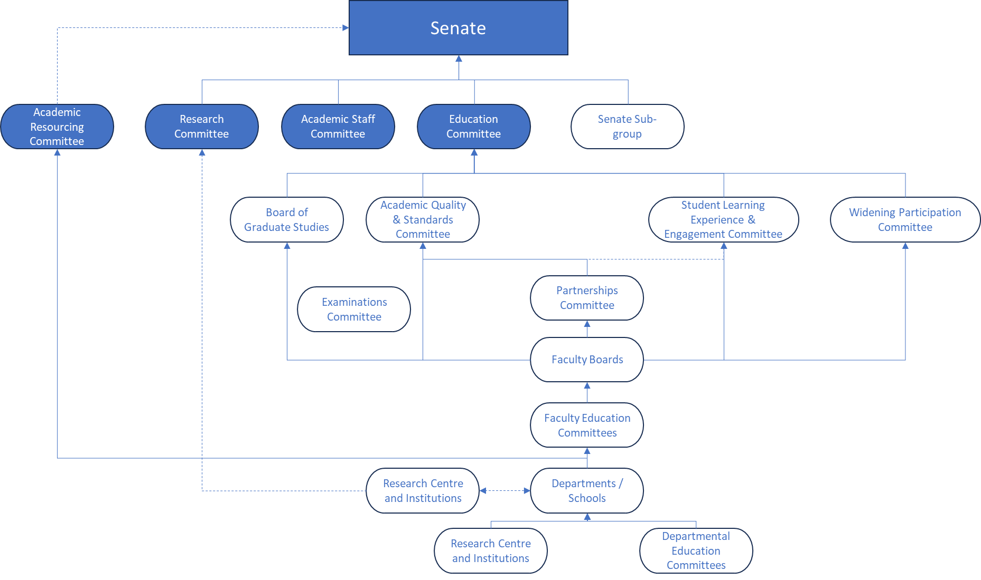
Gathering

Feedback

Gathering Feedback
To effectively represent your cohort, you need to gather feedback from your peers.
Some feedback mechanisms that have been used in the past are:
- Social media groups such as WhatsApp.
- Survey questions.
- After/before-lecture discussions.
- Teams Groups
It is important to use a range of ways to gather feedback to be accessible to the diverse range of students at Warwick. Not everyone uses Whatsapp, likes to talk in person about issues, or attend the lectures you attend due to differences in module choices.
We encourage our reps to gather feedback in ways that allows everyone on the course to be actively involved in giving opinions and comments. Make sure that gathering feedback happens on a regular basis and provide evidence when any constructive comments are given.
To help, we’re setting up a Whatsapp Communication group for Course Reps. This is where our reps can meet, collaborate, share feedback, and communicate with students in their cohort.

Presenting Feedback
Before you attend the SSLC meetings, be sure to bring a balance of positive comments and an action point that can be worked upon to improve your experience of the course. Any action points need to be supported with evidence. This can range from a collection of comment feedback or even paper evidence. When you have presented your feedback, make sure that you update your cohort on developments and progress.

‘We encourage our reps to gather
feedback in ways that allows everyone on the course’

12 13

Where to Present Feedback FAQs

As a rep, you will receive a range of feedback, some of which may concern issues of a personal nature that need specialist support. If this occurs, you will need to direct it
through the appropriate alternative channels. Here are some examples of feedback that you may get and where to direct it:

When do we elect a SSLC Chair and/or Secretary?
Chairs and Secretaries are elected at your first SSLC meeting of the Academic Year between the Course Reps within the

What should I do if my role as a Rep is affecting my studies/welfare?
The role of a Course Rep is very flexible when it comes to how much you can get

SSLC Feedback

Course Books Timetabling Module Choices Study Space
Assessment Changes
Dissertation/Theses Resources
SU Advice Centre

Plagiarism Changing Course
Issues with Certain Academics
Academic Appeals Mitigating Circumstances
Faculty Reps

Parking
Food & Drink Outlets Printing Credits University Policies Research Funding
SSLC meeting. The Academic Convenor will organise the first SSLC and the SSLC Chair/ Secretary will organise the rest of the meetings for the Academic Year.
If you would like to become the Chair or Secretary for your SSLC, you can put yourself forward during the first SSLC
Meeting. If you want to find out more about the role, you can go to the Rep Resources page of the Warwick SU website.

I haven’t been contacted about my first SSLC
involved. If you are feeling overwhelmed by the role, chat to your faculty support staff member in the SU Education Team either in SUHQ or via email. We will be able to help you manage your role better with a range of options.

Jargon Buster
Academic Convenor – The nominated Academic Staff member who helps arrange the SSLC and ensure issues raised are given to the right areas of the

If you are not sure if a student issue should be dealt with as a complaint, get in contact with the SU Voice Team.

meeting. What do I do?
The first SSLCs of the year take place in the second half of Term 1. The Academic Convenor organises the first meeting
of the year. If you haven’t heard by mid- November, contact your Academic Convenor. If you do not know who your Academic Convenor is, contact the SU Voice Team staff member who supports your faculty.

How do I contact the students I represent?
If you are having trouble contacting your students, contact your Academic
Convenor who can help you with a range of digital and physical ways to gather feedback from your student body. If you don’t know who your Academic Convenor is, contact the SU Voice Team.
Course/Department
SU Voice Team – The staff members in the SU who ensure that SSLC runs across the University and work with the Faculty Reps to escalate feedback.
Minutes – This is a record of the meeting written by the SSLC Secretary. It is not a word for word recap but ensures that all the points raised and main parts of the meeting is written down.
Agenda – This is an order of what will be discussed at the meeting. This is written by the SSLC Chair and helps them
when running the meeting and ensures everything is covered.

The SU Advice Centre can be contacted via:
Email:
advice@warwicksu.com

Online:
warwicksu.com/help-support/ contact
Call:
02476 572824
Visit:
Advice Centre, SUHQ, 2nd floor
14
15

Notes Notes

....................................................................
....................................................................
....................................................................
....................................................................
...................................................................
...................................................................
....................................................................
....................................................................
....................................................................
....................................................................
....................................................................
....................................................................
....................................................................
....................................................................
....................................................................
...................................................................
....................................................................
....................................................................
....................................................................
....................................................................
....................................................................
....................................................................
....................................................................
....................................................................
....................................................................
....................................................................
....................................................................
....................................................................
....................................................................
....................................................................
....................................................................
....................................................................
....................................................................
....................................................................
....................................................................
...................................................................
....................................................................
....................................................................
....................................................................
....................................................................
....................................................................
....................................................................
...................................................................
....................................................................

....................................................................

....................................................................

....................................................................
....................................................................
....................................................................
....................................................................
....................................................................
....................................................................
....................................................................
....................................................................
....................................................................
....................................................................
....................................................................
....................................................................
....................................................................
....................................................................
....................................................................
....................................................................
....................................................................
....................................................................
....................................................................
....................................................................
....................................................................
....................................................................
....................................................................
....................................................................
....................................................................
....................................................................
....................................................................
...................................................................
....................................................................
....................................................................
....................................................................
....................................................................
....................................................................
....................................................................
....................................................................
....................................................................
....................................................................
....................................................................
....................................................................
....................................................................
....................................................................
....................................................................
....................................................................
....................................................................
....................................................................
....................................................................
....................................................................
....................................................................
....................................................................

16 17

Notes Notes

....................................................................
....................................................................
....................................................................
....................................................................
...................................................................
...................................................................
....................................................................
....................................................................
....................................................................
....................................................................
....................................................................
....................................................................
....................................................................
....................................................................
....................................................................
...................................................................
....................................................................
....................................................................
....................................................................
....................................................................
....................................................................
....................................................................
....................................................................
....................................................................
....................................................................
....................................................................
....................................................................
....................................................................
....................................................................
....................................................................
....................................................................
....................................................................
....................................................................
....................................................................
...................................................................
....................................................................
....................................................................
....................................................................
....................................................................
....................................................................
....................................................................
...................................................................
....................................................................

....................................................................

....................................................................
....................................................................
....................................................................
....................................................................
....................................................................
....................................................................
....................................................................
....................................................................
....................................................................
....................................................................
....................................................................
....................................................................
....................................................................
....................................................................
....................................................................
....................................................................
....................................................................
....................................................................
....................................................................
....................................................................
....................................................................
....................................................................
....................................................................
....................................................................
....................................................................
....................................................................
....................................................................
...................................................................
....................................................................
....................................................................
....................................................................
....................................................................
....................................................................
....................................................................
....................................................................
....................................................................
....................................................................
....................................................................
....................................................................
....................................................................
....................................................................
....................................................................
....................................................................
....................................................................
....................................................................

....................................................................
....................................................................
SSLC Templates, Faculty Reports, Briefings and other important resources can be found at:
warwicksu.com/student-voice/academic-representation/course-rep-resources

18 19

sslc@warwicksu.com
warwicksu.com/sslc October 2024

